PROJECT DOCUMENTATION AND REPORT:

**LONG TERM INTERNSHIP ON SALESFORCE PROJECT TITLE : VECHICLE MANAGEMENT SYSTEM USING SALESFORCE OF A CANDIDATE WITH INTERNAL MARKS**

FACULTY MENTOR : K ANJANEYULY

TEAM ID : LTVIP2023TMID08784  **TEAM SIZE : 5**

**TEAM LEADER :CHINTHALAPUDI SAHITHYA**

**TEAM MEMBERS: 1. DUVURI DHARANI**

**2. CHAKALA MOUNIKA**

**3. G MEENAKSHI**

**4. TIRUMULASETTY BHAVYASREE**

**VECHICLE MANAGEMENT SYSTEM USING SALESFORCE OF A CANDIDATE WITH INTERNAL MARKS**

**Introduction :**

The Vehicle Management System (VMS) is an application for the Automotive industry. It supports, in the area of Sales & Services, the business processes that you require as vehicle importer when dealing with your original equipment manufacturers (OEMs) and your dealers in new and used vehicle sales .

What are the advantages of VMS?

Virtual Machine Benefits Personalization: There is great flexibility and personalization with virtual machines. ...

Virtualization: ...

Backup by VM at a time: ...

Easy Recover/Failover: ...

Run multiple Operating Systems: ...

OS and Application Updates: ...

The Bottom Line:

Set Up and Maintain Retail Execution

Vehicle Management

Create and manage vehicle records to optimize the usage of your trucks and trailers that carry inventories to stores. To track the vehicles that carry goods out of a warehouse, assign them to that warehouse.

REQUIRED EDITIONS

Available in: Lightning Experience in Professional, Enterprise, and Unlimited Editions that have Consumer Goods Cloud enabled.

Here’s a visual representation of how vehicles are associated with warehouses.

Vehicle management

Add a Vehicle

Create a vehicle record for each vehicle that’s used to transport goods to retail stores.

Assign a Warehouse to a Vehicle

To track the vehicles carrying goods out of an warehouse, assign a warehouse to a vehicle.

What is the use of vehicle management system?

A vehicle management system is a software system — or platform — that serves to manage commercial fleets of vehicles, such as cars, vans or trucks — or even heavy equipment — to ensure they're utilized safely, efficiently and professionally, while making sure they're well maintained and high-performing.

What is vehicle management system summary?

VMS is a complex information system that gathers, stores, processes, monitors data and generates extensive MIS reports for management to have complete track of their vehicles and relevant expenses.

What is the purpose of the vehicle management system?

A vehicle management system is a software system — or platform — that serves to manage commercial fleets of vehicles, such as cars, vans or trucks — or even heavy equipment — to ensure they're utilized safely, efficiently and professionally, while making sure they're well maintained and high-performing.

What are the objectives of vehicle management system?

To assist in the tracking of vehicles operation and the planning of maintenance (i.e.: replacement of spare parts, etc.) that is important to avoid any damage/unexpected problem that might occur in the future that may cause hindrance to the operation and/or risking the safety of the drivers and passengers.

**Create a salesforce org** – We have created a developer org and activated the account.

Salesforce signup link : <https://developer.salesforce.com/signup>

Salesforce Login link : <https://login.salesforce.com>

In the below video we have logged into Salesforce org.



**Object:-**  
In your Salesforce org, click Setup and select Setup to open Setup.

1. Click the Object Manager tab. If you don’t see it, enter Object Manager in the Quick Find box.
2. On the Object Manager Object Manager page, click Create | Custom Object.  
   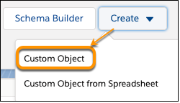
3. For Label, enter whatever you want to call your custom object. Notice that the Object Name and Record Name fields auto-fill.
4. For Plural Label, enter the plural form of your custom object name.
5. Check the box for Launch New Custom Tab Wizard after saving this custom object.
6. Leave the rest of the values as default and click Save.
7. On the New Custom Object Tab page, click the Tab Style field and select a style you like. The style sets the icon to display in the UI for the object.
8. Click Next, Next, and Save.

Vehicle Object:

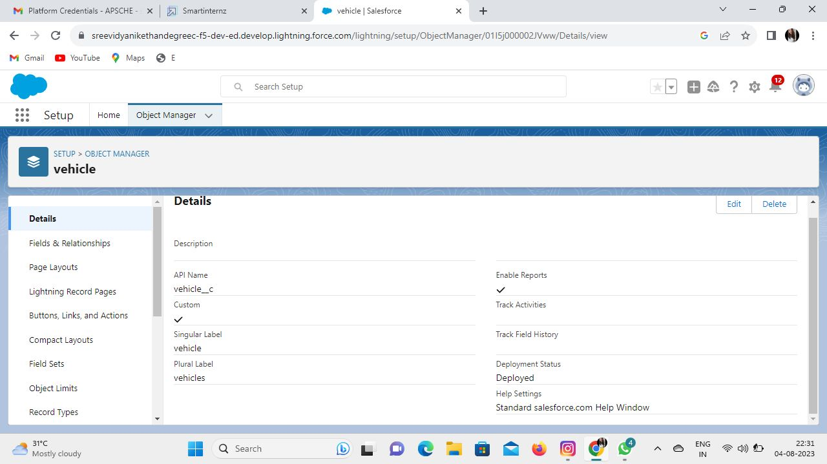

Driver Object:

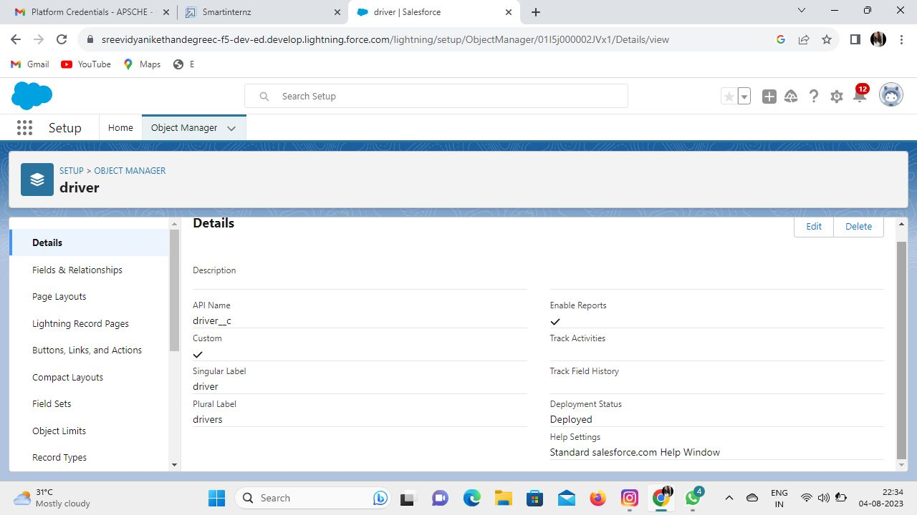

Traveler Object:

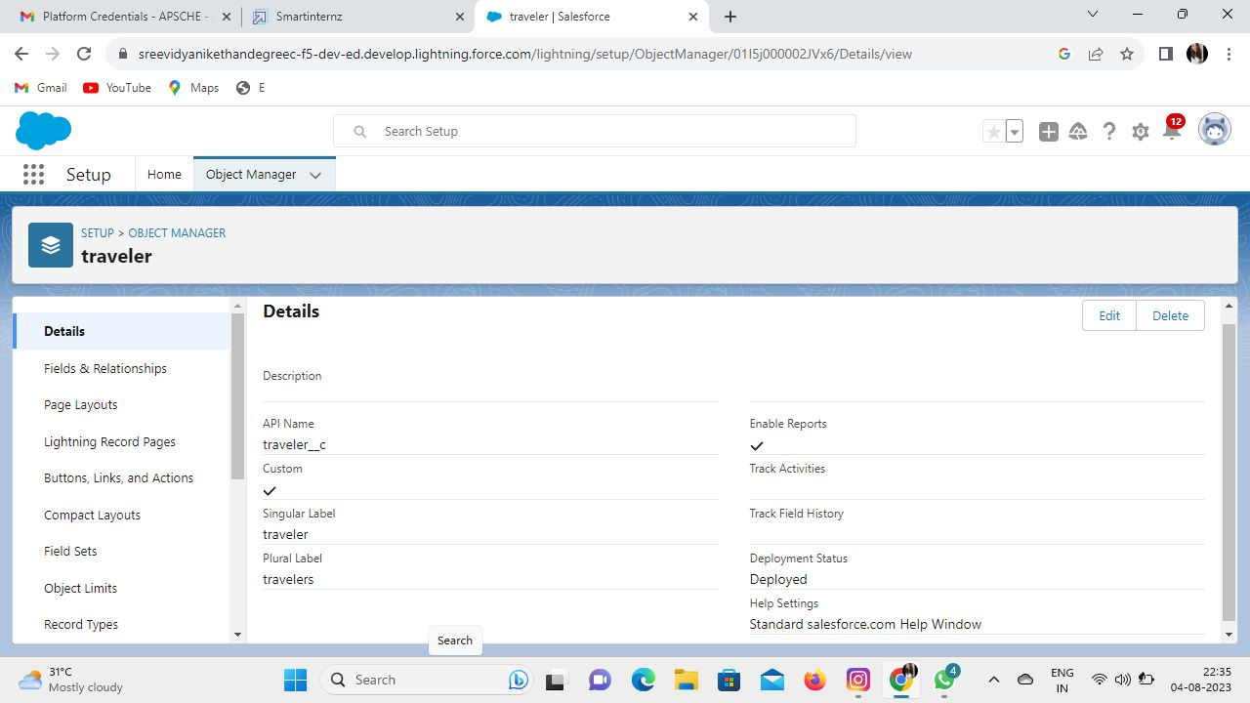

**Fields and relationships**:-

From Setup, go to Object Manager |

1. On the sidebar, click Fields & Relationships.
2. Click New.
3. Choose Lookup Relationship and click Next.
4. For Related To, choose Contact. ...
5. Click Next.
6. For Field Name, enter Contact, then click Next.
7. Click Next, Next, and Save.

Fields in Vehicle Object:

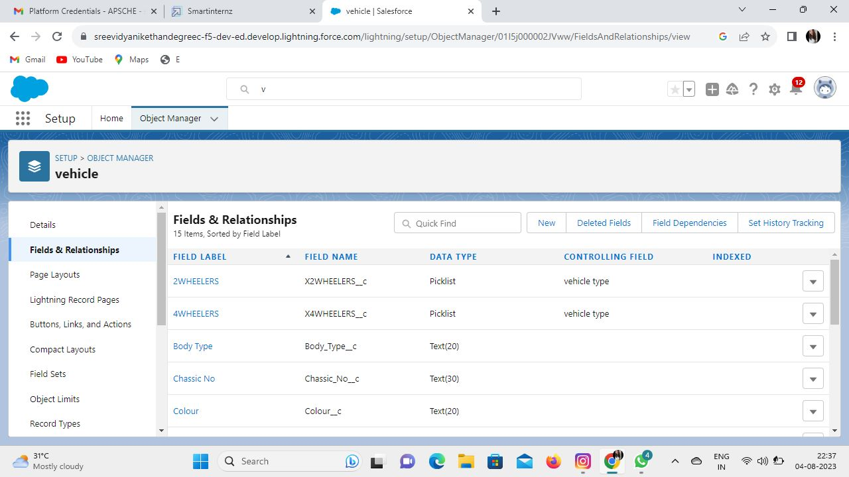

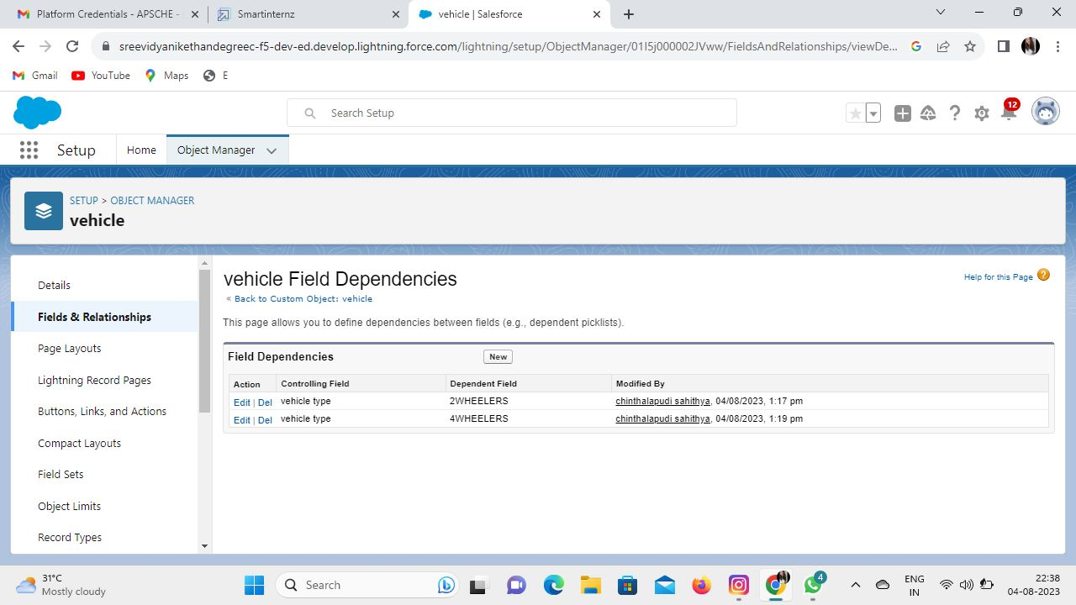

Fields in Traveler Object:-

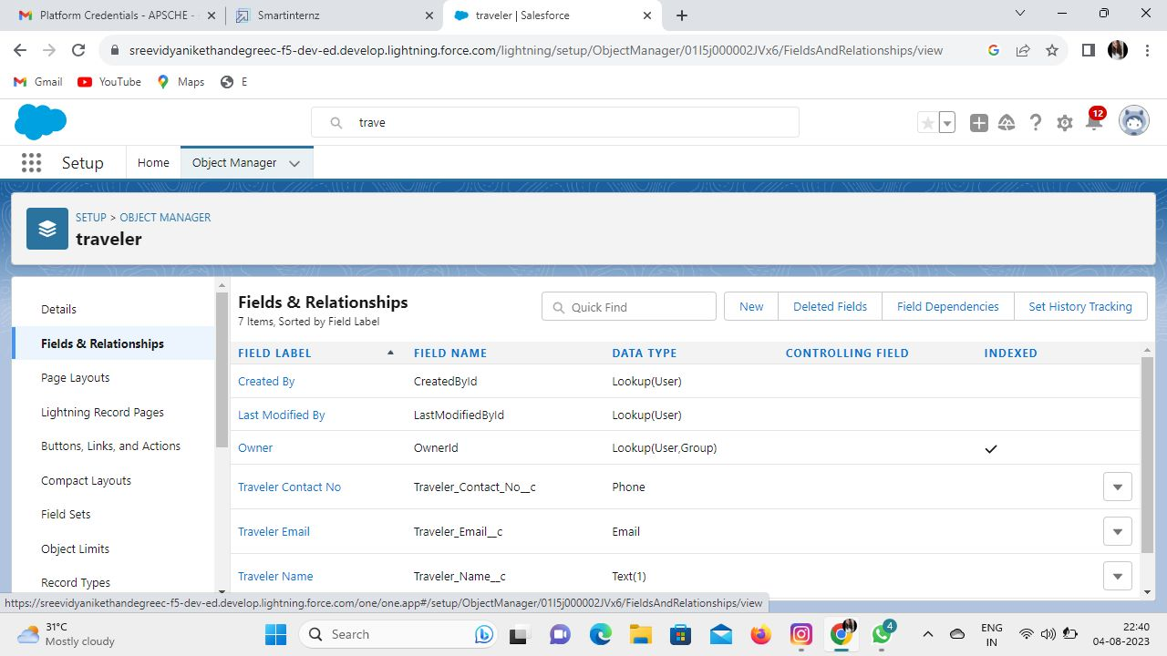

Fields in Driver Object:-

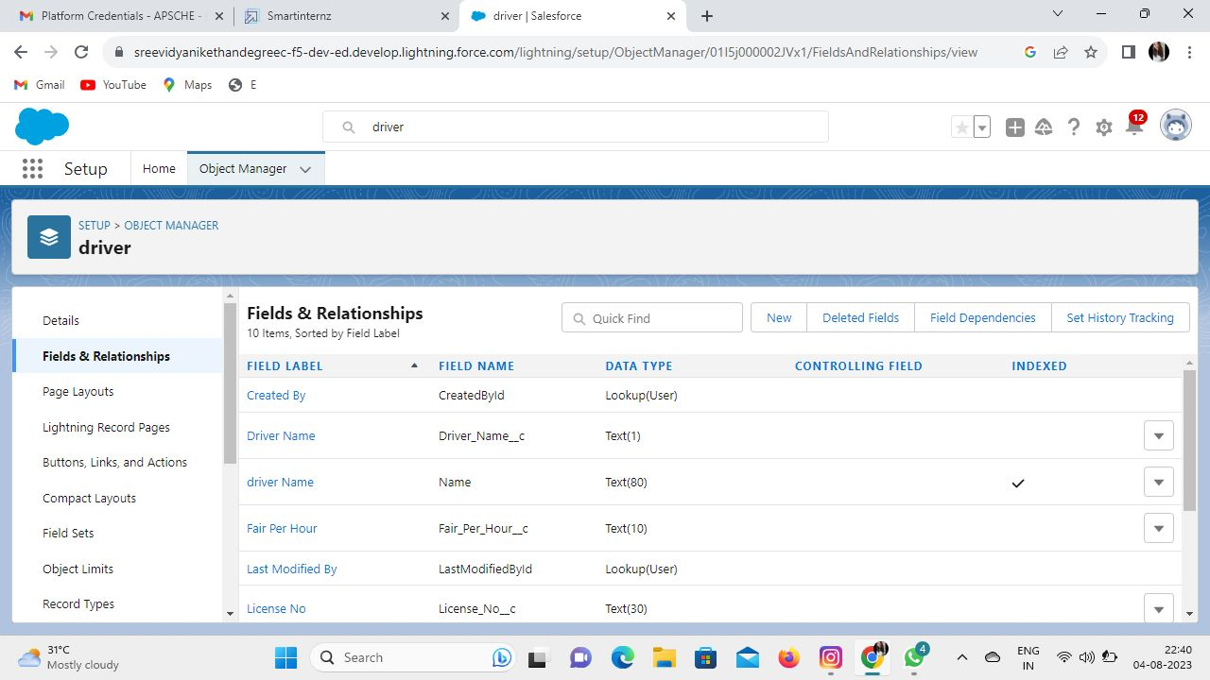

Fields in Opportunity Object:-

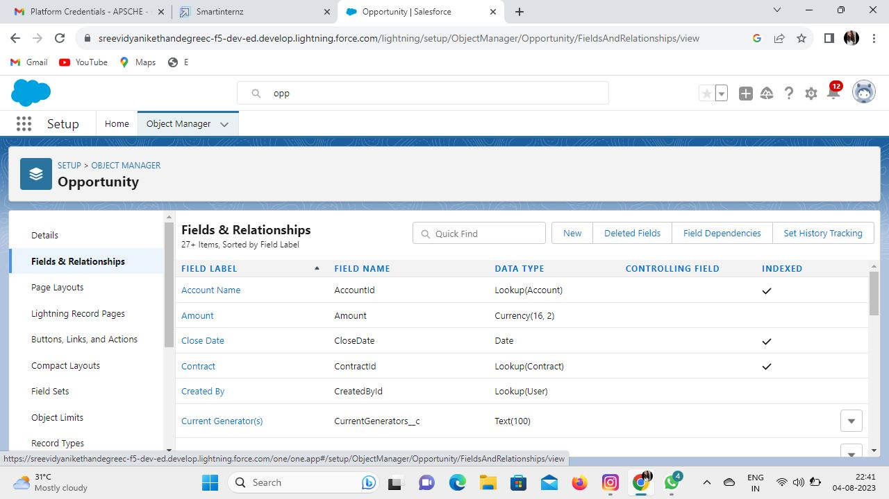

**Page Layout Setup:** **-**

1. From Setup, click Object Manager and select Account.
2. Click the Page Layouts link, then click New.
3. Select Account Layout from the Existing Page Layout picklist.
4. Enter Customer Account Layout for Page Layout Name. ...
5. Click Save.

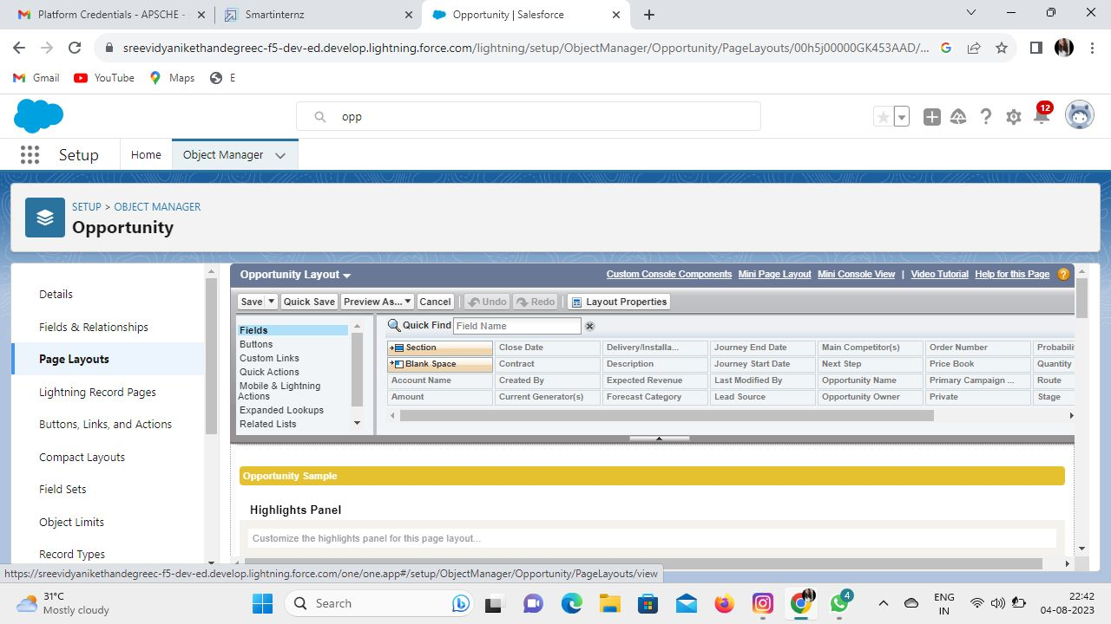

**Lightning App;-**

* + 1. From Setup, enter App Builder in the Quick Find box, then select Lightning App Builder.
    2. Click New.
    3. Select App Page and then click Next.
    4. Give your app page a label, and then click Next.The label can be up to 80 characters.

1. Select a page template and click Done.
2. Drag the components that you want onto the page.

Drag components up and down to rearrange them. You can also click a component’s top or bottom border to create an insertion point (Insertion Point Icon) for the next component.

1. Click each component on the page to configure its properties.
2. Click in the empty area of the canvas or on the Page link in the breadcrumb to configure the page properties.

The Description field is limited to 255 characters. The API Name field is limited to 80 characters, but if you have a namespaced org, we recommend using fewer than 65 characters. When you create a Lightning page, the API name is derived from the first 40 characters of the label that you give the page.

1. Optionally add global actions to your page.
   1. In the page properties, click Select.
   2. Add, remove, or reorder the actions for your page.

Actions you select appear on the page’s action bar and in the highlights panel at the top of the page in Lightning Experience. An app page is the only type of Lightning page that you can add actions to in this way. Other Lightning pages derive their actions from the object and global page layouts.

* 1. Click OK.

1. Click Save when you’re done editing your page.

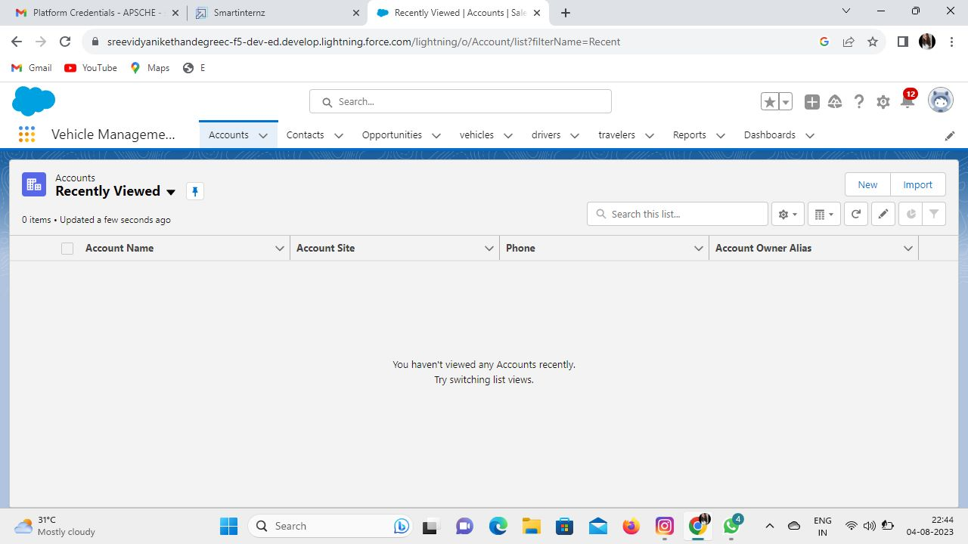

**Profiles:-**

* 1. From Setup, enter Profiles in Quick Find, then select Profiles.
  2. Clone the Standard User profile.
  3. Give the profile a name to identify the type of user, such as Reviewer or Service Dispatcher .
  4. Save your changes.
  5. Click Edit and give permission to Emergency Program Management objects.

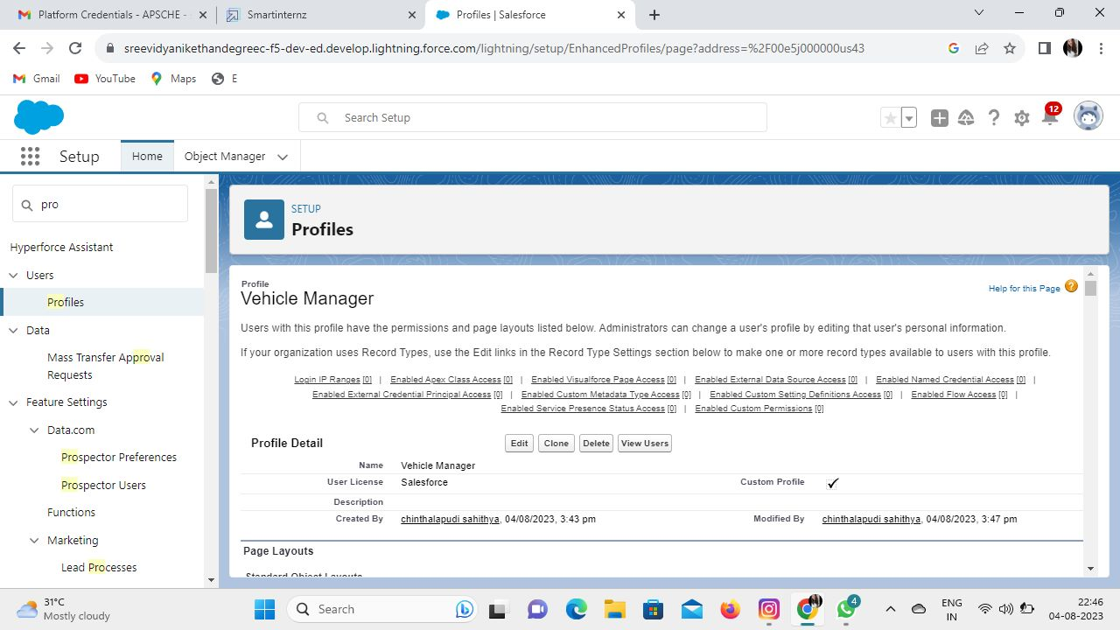

**Users:-**

* 1. Read the guidelines for adding users.
  2. From Setup, in the Quick Find box, enter Users , and then select Users.
  3. Click New User.
  4. Enter the user's name and email address and a unique username in the form of a email address. ...
  5. In Professional, Enterprise, Unlimited, Performance, and Developer Editions, select a Role .

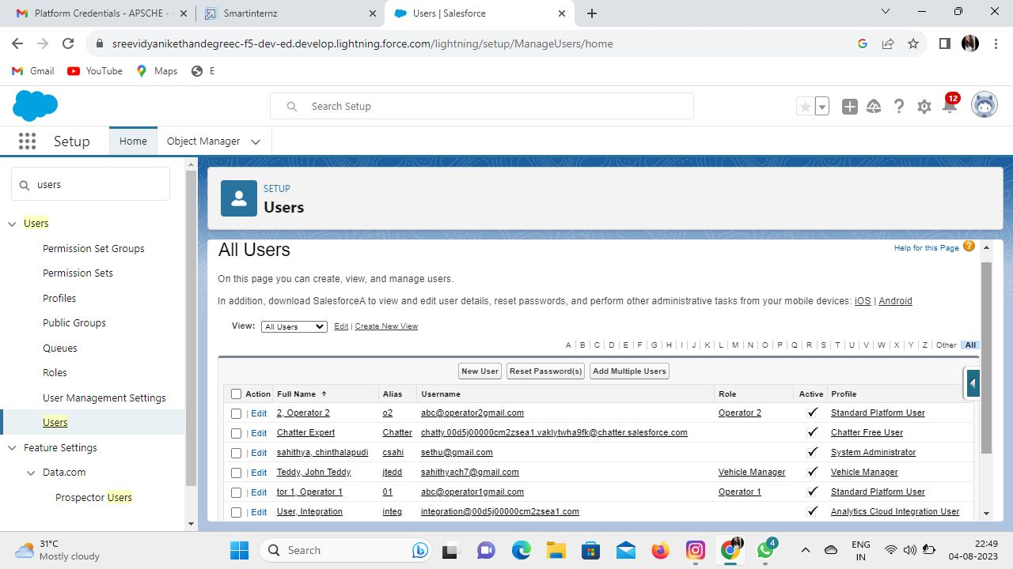

**User Adoption:-**

* 1. Stakeholder Support. ...
  2. Optimal Training Approach. ...
  3. Triggered Motivation. ...
  4. Reporting on Salesforce User Adoption. ...
  5. Utilize AppExchange. ...
  6. Hire a Salesforce Admin. ...
  7. Make Clean Data a Priority. ...
  8. Right Communication Strategy.

**Reports And Dashboards**

**Reports:-**

* 1. Click the App Launcher app launcher icon and select Space Station Construction.
  2. Click the Reports tab and click New Report.
  3. Click the Other Reports category.
  4. Select Space Station with Supplies and click Start Report. (If you don't see the Space Station with Supplies report type, go to Setup and click Object Manager. Next to Supply click the drop-down, then click Edit. Under Optional Features, check Allow Reports. Click Save. Then go back and create the report.)
  5. In the Add column search, search for Quantity, Unit Cost, and Total Cost fields and add them as columns. (You can also drag the fields from the Fields pane into the Columns section.)
  6. In the Add group search, enterSpace Station Name and select Space Station Name. This will separate the report by individual Space Station records.
  7. Click the Update Preview Automatically toggle to view column menus.
  8. Open the menu on the Quantity column and select Summarize, then deselect Sum.
  9. Open the menu on the Unit Cost column and select Summarize, then deselect Sum.
  10. Click Save & Run, enter Supplies for the Report Name and click Save.

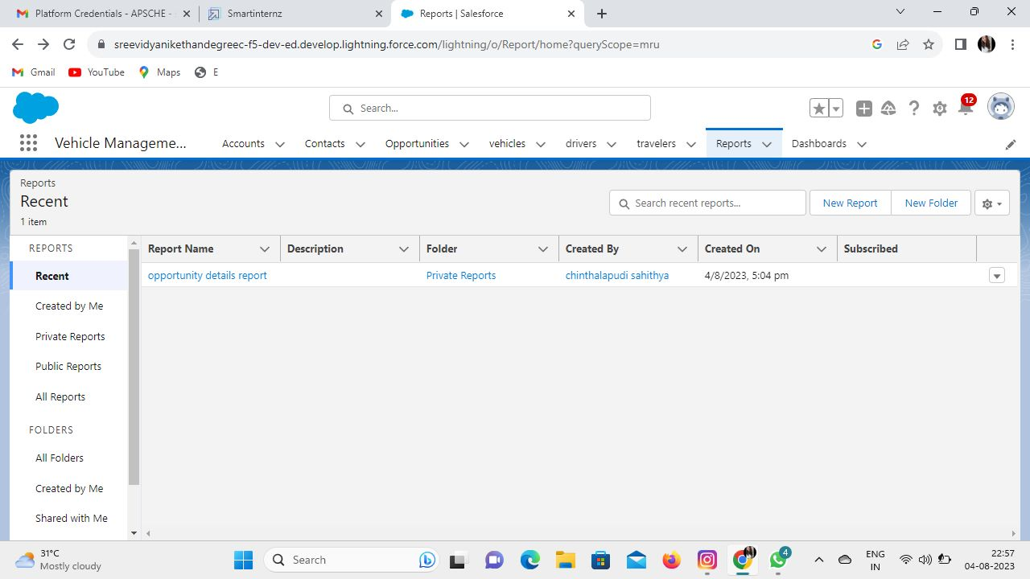

**Dashboards:-**

1. Click the Dashboards tab.
2. Click New Dashboard.
3. Name the dashboard Construction and click Create.
4. Click +Component.
5. Search and select the Supplies report and click Select.
6. Select the Vertical Bar Chart component and click Add.
7. Click Save and then Done.

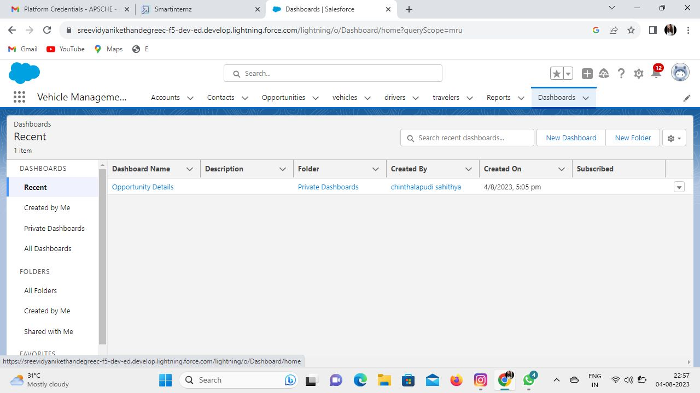

**Conclusion:-**

**Reporting:-**

Create and manage vehicle records to optimize the usage of your trucks and trailers that carry inventories to stores. To track the vehicles that carry goods out of a warehouse, assign them to that warehouse.